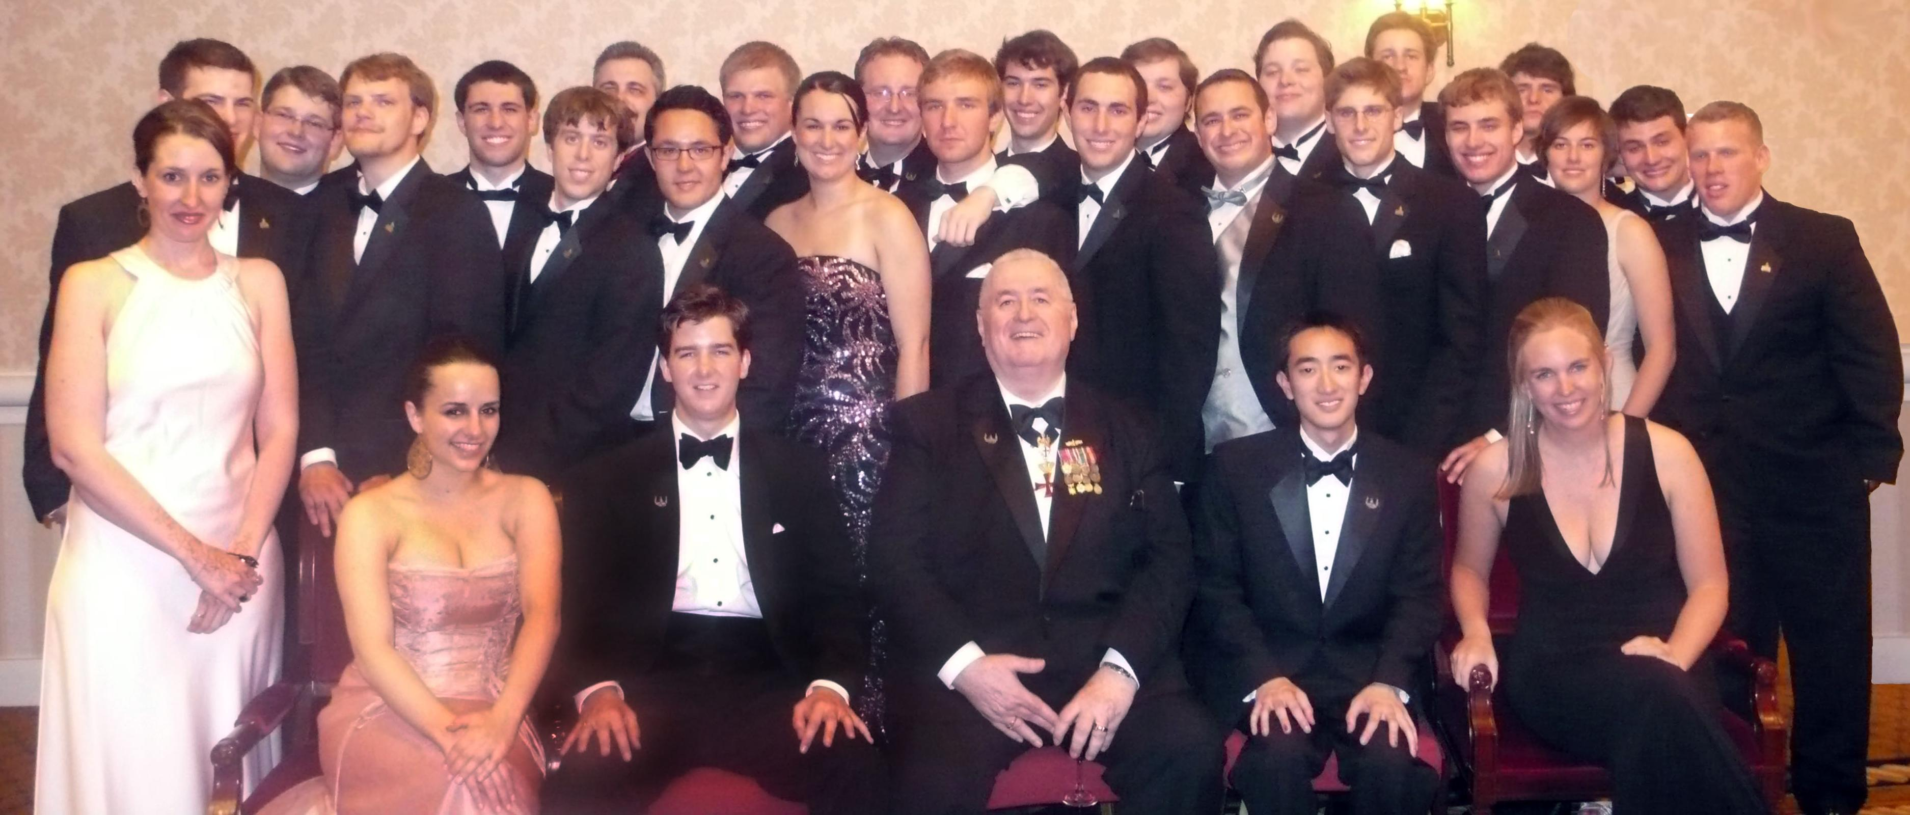

The Washington Scholars Interns at the DUB Ball: June 2008

Front Row: Sarah Murphy (Tufts University), Lena Chuzhin (Georgetown University), Christopher Bond (Tulane University), Rear Admiral James J. Carey (Chairman, Future Leaders for America Foundation, Inc.), Jason Nguyen (University of Maryland), Nancy Gephart (Williams College)

Second Row: Ian Fijolek (University of Illinois), Steven Kelch (Massachusetts Institute of Technology), Kenneth Abbott (University of Maryland), Ruben Henriquez (University of Pennsylvania), Lori Eaton (California University of Pennsylvania), Andrew Biros (University of Pennsylvania), Mark Rosenthal (Pennsylvania State University), Dan Backer (George Mason Law), Richard Vanderpool (Pennsylvania State University), Paul Kaser (University of Michigan), Veronica Kersten (Georgia Institute of Technology), Ross Kazer (University of Massachusetts)

Back Row: Matthew Cujak (Syracuse University), Andrew Serrao (New York University), MacLane Key (Harvey Mudd College), Nicholas Morgan (Princeton University), Jason Murphy (Tulane University), Peter Johnson (Tulane University), John Flynn (University of Wisconsin), Michael Flynn (University of Wisconsin), Preston Postlethwaite (Cornell University), Aaron Frye (University of Washington), Austin Carson (University of Georgia)

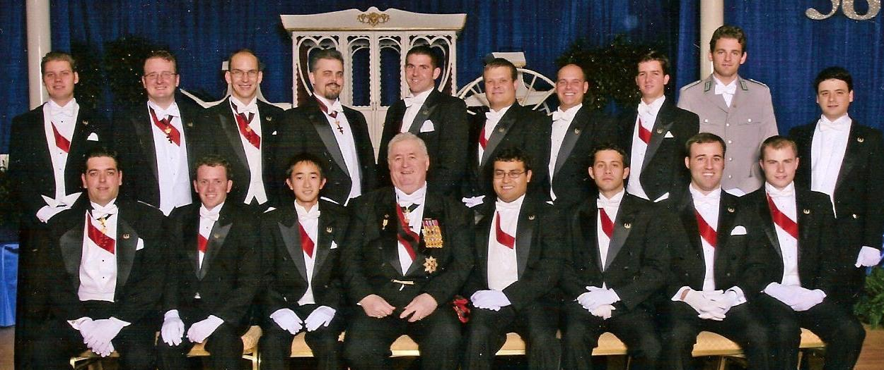

The Washington Scholars Floor Committee Delegation: November 2007

Front Row: Torsten Trupp (University of Illinois), Eric Kenney (University of Connecticut), Jason Nguyen (University of Maryland), Rear Admiral James J. Carey (Chairman, Future Leaders for America Foundation, Inc.), Fernando Cortes (University of Illinois), Joseph Kotalik (University of Illinois-Chicago), Jordan Spore (University of Wisconsin), John Vehmeyer (University of Illinois)

Back Row: Alexander Reventlow (University of Illinois), Jason Murphy (Tulane University), Mark Williams (Tulane University), MacLane Key (Harvey Mudd College), Darren Littell (University of Washington), Peter Forsberg (University of Texas), Eric Zito (Pennsylvania State University), Chris Bond (Tulane University), Philipp Gallhöfer (Johns Hopkins University), AJ Fluehr (Pennsylvania State University)

CONGRATULATIONS
TO THE DEBUTANTE CLASS OF 2008
FROM THE OFFICERS AND SENIOR SCHOLARS
OF
The Washington Scholars Fellowship Program
Of Washington, DC

“Training Tomorrow’s National Leaders Today”

www.WashingtonScholars.org
www.FutureLeadersForAmerica.org

