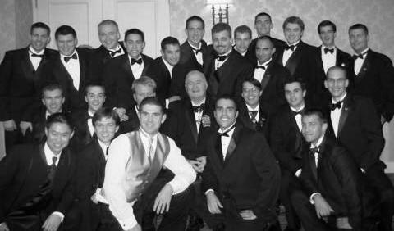

Washington Scholars at the DUB Ball: June, 2006
Back Row [L to R]: John Michael Poreba of Penn State University, Brian Scott Eaton of Penn State University, Robert Francis Trombley of the University of Michigan,, Nicholas Anthony Domingues of the University of Maryland, Andrew Marzzacco of Penn State University, Anthony Roman Napolitano of the University of California Los Angeles, MacLane Colin Key Esq. of Harvey Mudd College, John Robert Vehmeyer Jr. of the University of Illinois, {Upper} Brian Albert Foderaro of the University of Connecticut, {Lower} Michael Brooks Stackhouse of the University of Notre Dame, Ryan Christopher Diller of the University of Maryland, Christopher Joseph Bond of Tulane University, Brian Clarke McManus Esq. of the University of Massachusetts; Middle Row: Jonathan Robert Stott of the University of Pennsylvania, Scott Brandon Galla of the University of Wisconsin, John Joseph Herzog of the University of Illinois, Founder & Washington Scholars Cotillion Chairman Rear Admiral James J. Carey of Northwestern University, Washington Scholars Program Chairman Brian Scott Phillips of the University of Texas, Christopher Jordan Guarda of the University of Maryland, Mark Benjamin Williams of Tulane University; Front Row: Yangzhi “Z” Zhao of the University of Michigan, Gary Andrew Mitchell of Seton Hall University, Darren Raymond McDade-Littell of the University of Washington, Brian Alan Christiansen of Yale University, Joseph David Kotalik of the University of Illinois

CONGRATULATIONS
TO THE DEBUTANTE CLASS OF 2006

FROM THE OFFICERS AND SENIOR SCHOLARS
Of
The Washington Scholars Fellowship Program
Of Washington, DC

“Training Tomorrow’s National Leaders Today”

www.washingtonscholars.org

